**//Experiment no-09**

using System;

using System.Text.RegularExpressions;

namespace RegExApplication

{

class Program

{

private static void showMatch(string text, string expr)

{

Console.WriteLine("The Expression: " + expr);

MatchCollection mc = Regex.Matches(text, expr);

foreach (Match m in mc)

{

Console.WriteLine(m);

}

}

static void Main(string[] args)

{

string str = "A Thousand Splendid Suns";

Console.WriteLine("Matching words that start with 'S': ");

showMatch(str, @"\bS\S*");

Console.ReadKey();

}

}

}

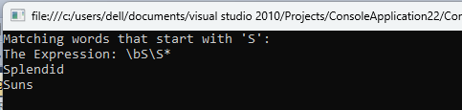

using System;

using System.Text.RegularExpressions;

namespace RegExApplication

{

class Program

{

private static void showMatch(string text, string expr)

{

Console.WriteLine("The Expression: " + expr);

MatchCollection mc = Regex.Matches(text, expr);

foreach (Match m in mc)

{

Console.WriteLine(m);

}

}

static void Main(string[] args)

{

string str = "make maze and manage to measure it";

Console.WriteLine("Matching words start with 'm' and ends with 'e':");

showMatch(str, @"\bm\S*e\b");

Console.ReadKey();

}

}

}

